**Review Worksheet: Protein/Amine/Peptide vs Steroid Hormones**

*Do these questions using your learning resources. Look at the “marks” to give you an idea of the level of detail required in the response (formative only – does not count towards your grade). At the end, mark your work, and fill in the reflection section. Questions marked * require you to use reasoning, inferring and application of knowledge to get the answer. It won’t be right there in the text.*

1: For each of the following pieces of information, circle whether they apply to amine hormones or steroid hormones.

(0.5 marks per correct answer – 9 marks total)

|  |  |
| --- | --- |
| **Information** | **Answer** |
| Binds to receptor on cell membrane | Amine / Steroid |
| Lipid (fat) soluble | Amine / Steroid |
| Activates genes to produce an enzyme or structural protein | Amine / Steroid |
| Shorter duration of action | Amine / Steroid |
| Aldosterone | Amine / Steroid |
| Triggers release of a second messenger | Amine / Steroid |
| Binds to receptor on nucleus or other organelles | Amine / Steroid |
| Changes shape of enzyme to turn it “on” or “off” | Amine / Steroid |
| Sex hormones such as Testosterone, Oestrogen and Progesterone | Amine / Steroid |
| Growth Hormone | Amine / Steroid |
| Water soluble | Amine / Steroid |
| Longer duration of action | Amine / Steroid |
| Cortisol | Amine / Steroid |
| Changes rate of transcription and translation to control rate of protein production | Amine / Steroid |
| Second messenger activates and amplifies enzymes that change cell functioning | Amine / Steroid |
| Passes through cell membrane | Amine / Steroid |
| Thyroxine | Amine / Steroid |
| Insulin | Amine / Steroid |

2: Look at the diagram and then complete the questions below.

(12 marks)

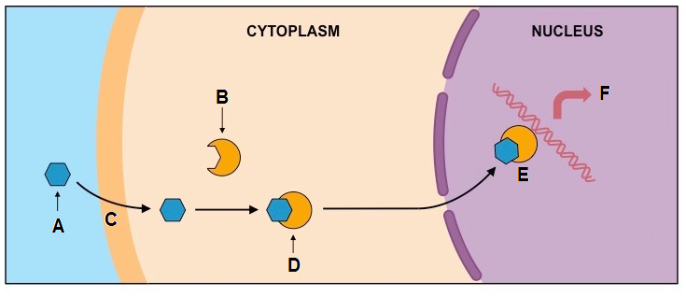

Is this an example of the mode of action for an amine hormone or a steroid hormone? (1)

*…………………………………………………………..*

Label structures / substances: (2)

A: *…………………………………………………………………………….*

B: *……………………………………………………………………………..*

Describe what is happening at the following points: (6)

C: *………………………………………………………………………………*

D: *………………………………………………………………………………*

E: ………………………………………………………………………………

What processes could happen at F, in response to E? (3)

*………………………………………………………………………………………………………………..*

*………………………………………………………………………………………………………………..*

*………………………………………………………………………………………………………………..*

*………………………………………………………………………………………………………………..*

*………………………………………………………………………………………………………………..*

*………………………………………………………………………………………………………………..*

4: Look at the diagram and complete the questions below:

(10 marks total)

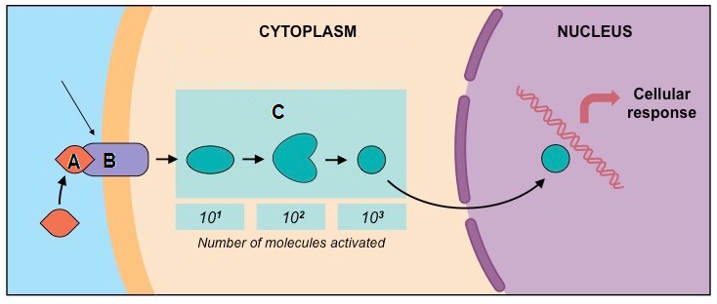

Is this an example of action of an amine hormone, or a steroid hormone? (1)

…………………………………………………………………………………

Label structures: (2)

A: *…………………………………………………………………………………..*

B: *…………………………………………………………………………………..*

Why does A need to bind to B at this location? (2)

*…………………………………………………………………………………………………….*

*…………………………………………………………………………………………………….*

*……………………………………………………………………………………………………*

*……………………………………………………………………………………………………*

What is released as a result of A binding to B? (1)

*……………………………………………………………………………………………………*

Describe what is occurring during process C*. (4)

*…………………………………………………………………………………………………….*

*…………………………………………………………………………………………………….*

*……………………………………………………………………………………………………*

*……………………………………………………………………………………………………*

*…………………………………………………………………………………………………….*

*…………………………………………………………………………………………………….*

*…………………………………………………………………………………………………….*

Go back and mark your work using the marking key provided. What score did you get? /31

*I included enough detail in my answers.*



*I was able to find information in the text/powerpoint presentation.*

*I was able to reason and infer where the information wasn’t directly in the text (questions with *).*

*I marked my work and wrote down any answers where I missed marks.*